# HW6_1

## Code

clc; clear;

close all

signal = csvread('Data.csv');

signal=signal*1000;

n=length (signal);

% 1. What is the first index of i in the for-loop? Is it 1? If not, then why?

% 2. What is the last index of i in the for-loop? Is it n?

% 3. What is the size of the slope array? Is it the same as that of signal?

% 1)

% % i=2 because we use looop and in loop we need i-1, so start index is 1 for acces value

% % 2)

% yes,n is the last index of loop...and first value is 0

% 3)

% no, slope is shorter n-1

t=1;

for i=2:n

slope(i-1)=(signal(i)-signal(i-1))/2;

end

% Anamoly detection using slopes

for i = 1:n-1

% we already compute sloop and use it

% sloop(i)=sloop(i)

if (slope(i)<=150)

% disp(slope(i))

new_signal(i) = signal(i+1);

end

end

% Determine the length of new_signal using the length() function.

n_clean = length(new_signal);

disp(['length of signal is: ',num2str(n)])

disp(['length of slope: ',num2str(length(slope))])

disp(['length of new clear signal is: ',num2str(n_clean)])

for i=1:n

if i == 1

moving_avg(i) = (signal(i)+signal(i+1))/2;

elseif i == n

moving_avg(i) = (signal(i-1)+signal(i))/2;

else

moving_avg(i) = (signal(i-1)+signal(i)+signal(i+1))/3;

end

end

figure()

x =1:n;

plot(x,signal,'b--'); % blue dot

hold on;

plot(x(1:n_clean),new_signal,'k'); % black line

plot(x,moving_avg,'r-+');

legend('signal','new_ signal','moving_ avg')

xlabel('x')

grid

ylabel('signal')

title('HW06_ 1')

## Output

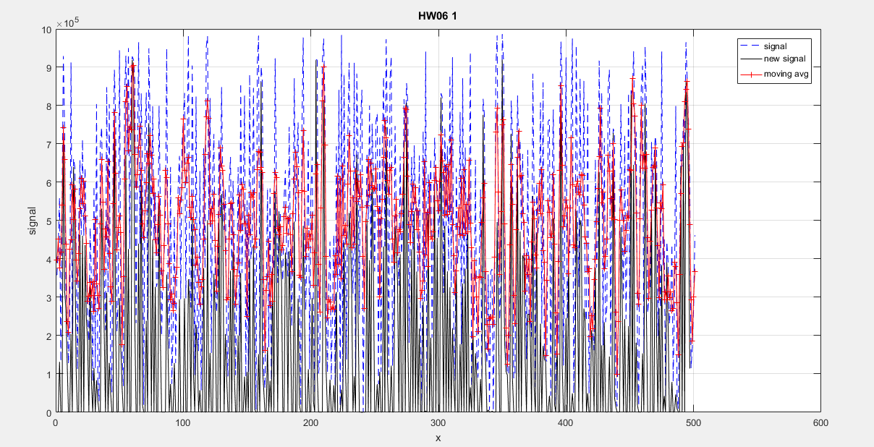



### Sloop test

clc

clear

signal = csvread('Data.csv');

data=signal(1:5);

t=1;

for i=2:length(data)

sloop_temp(i-1)=(data(i)-data(i-1) )/(2);

end

data

sloop_temp

### Output

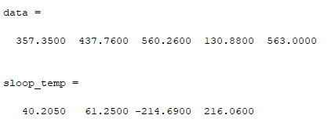

### By hand

# Question 02

## Code

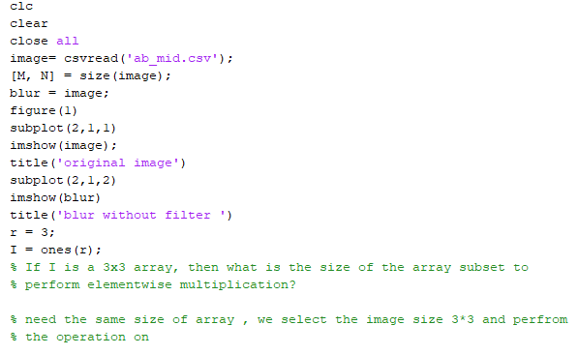

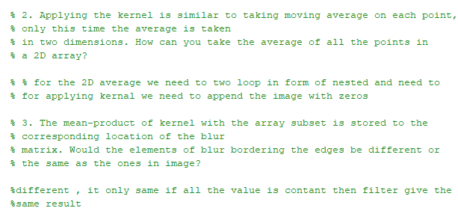

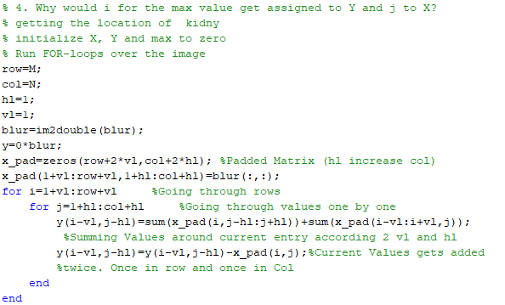

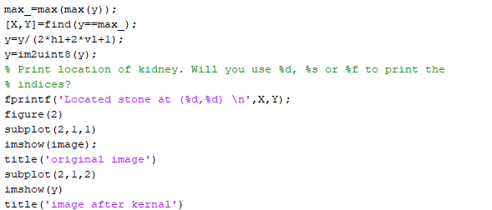

## Output

